Project Design Phase

Problem – Solution Fit Template
Date | 18 June 2026
Team ID | N/A
Project Name | Book-A-Doctor Healthcare Appointment Management System
Maximum Marks | 2 Marks
Problem–Solution Fit Template: The Problem-Solution Fit means identifying healthcare problems and validating that the Book-A-Doctor solution effectively solves them.
Purpose: Improve healthcare accessibility, appointment management and patient experience.

Template
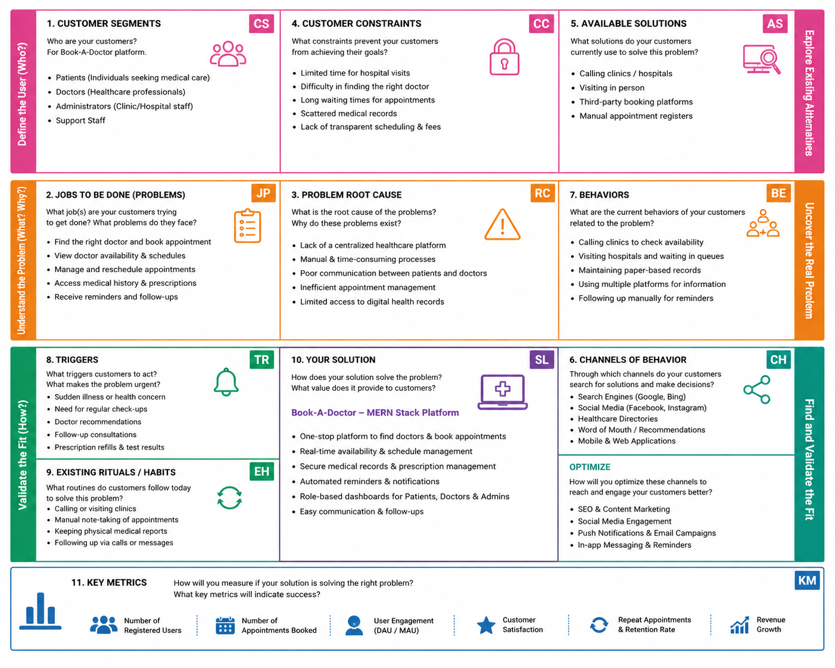

References
https://react.dev/
https://nodejs.org/
https://expressjs.com/
https://www.mongodb.com/docs/

